ccc

Fondren Library
Data @ Rice Workshop Series

Introduction to SPSS

Overview:
The software name originally stood for Statistical Package for the Social Sciences (SPSS)

Interface
Data View
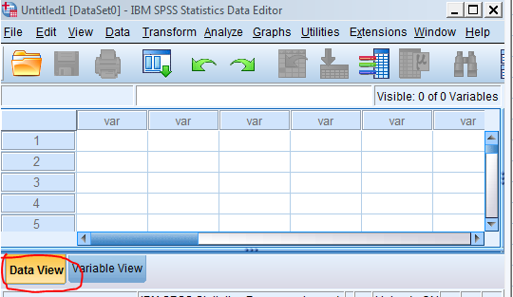
Variable View
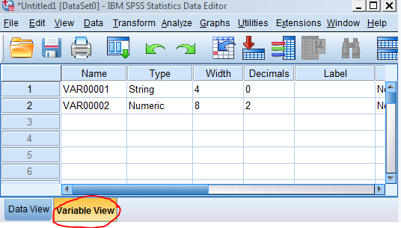
Data entry and change variable properties(name, type, lable, values, measures)

Useful options under the Menus
File
- New
- Open
- Recently used
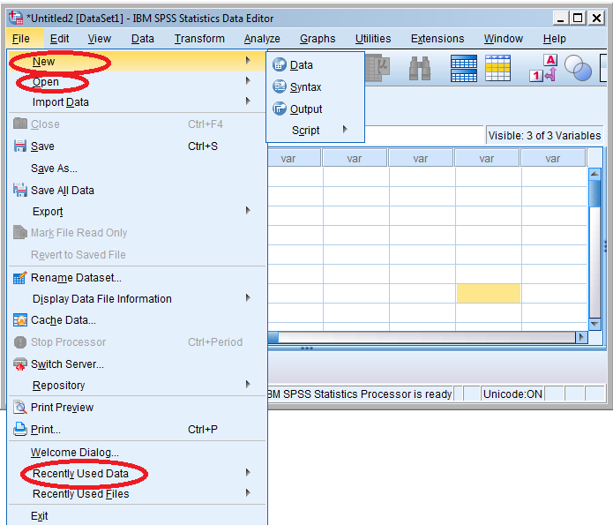

View
- Value lables

When it’s off, it shows the numaric values. When it’s on, it shows the text values imput in the Variable View
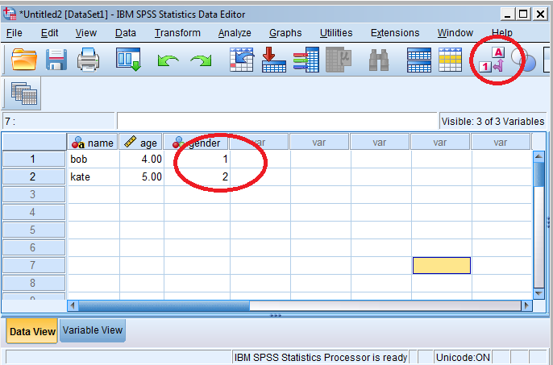

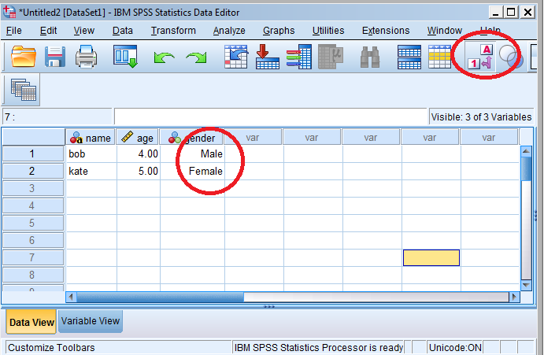

Data
- Identify duplicated case
- Transpose
- Merge files
- Select cases
- Weight cases
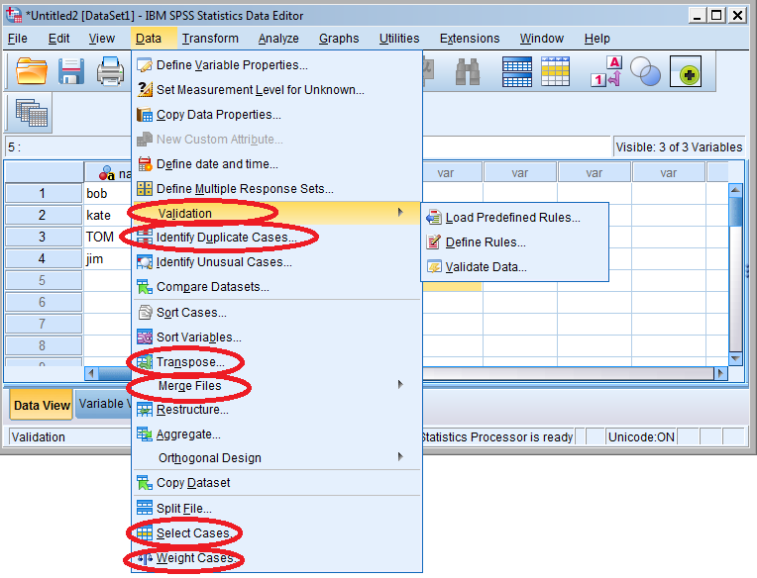

Transformation
- Compute variable
- Recode into different variable
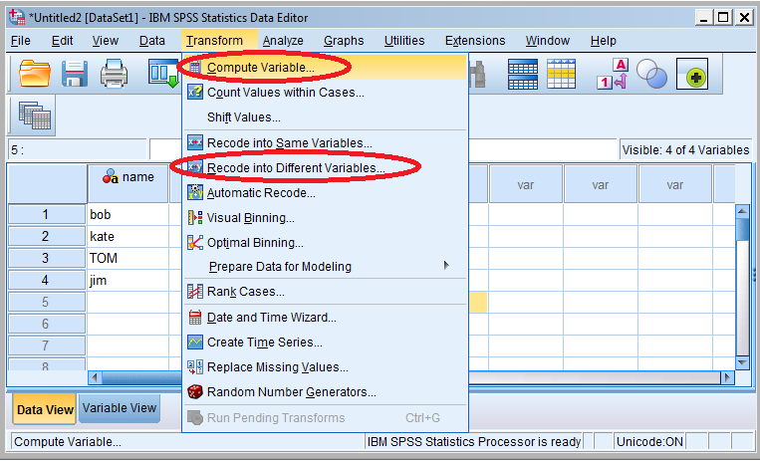

Analyze
- Report-OLAP Cubes
- Descriptive Statistics
- Compare Means
- Correlate
- Regression
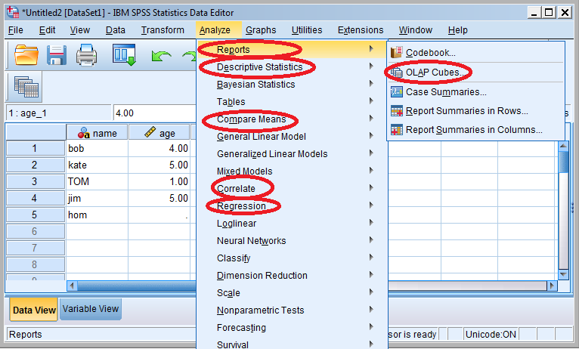

Graphs
- Chart Builder
- Graphboard Template Chooser
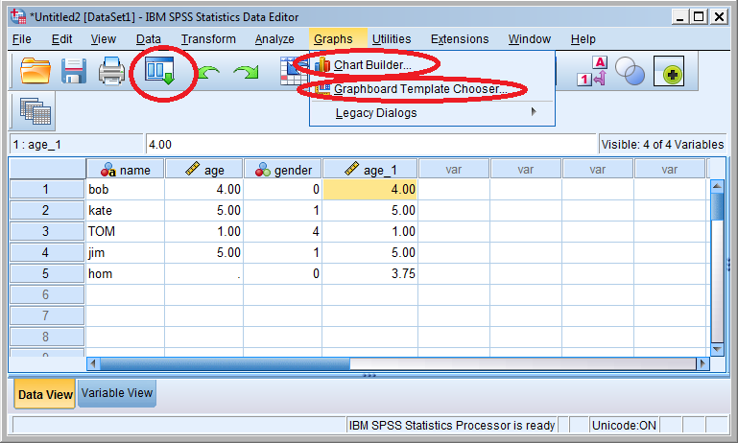
Recently used and Customize
Scrips
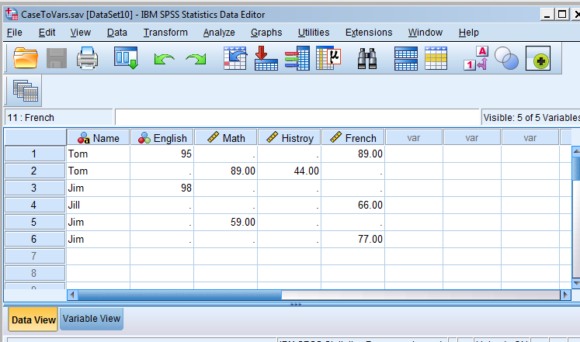

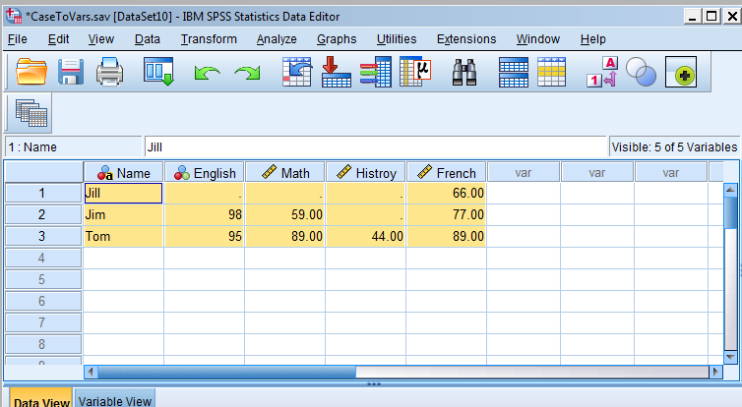

Terms
Data type
- String
- Numeric
Level of measures
- Norminal (No ranking, "Race", "Gender")
- Ordinal (Scale, "Strongly Disagree","Strongly Agree")
- Scale ("Age", "Height", "Income")
Cross Tablulation
Cross-tabluations are frequency distributitons for two variables together. It gives you a basic picture of how two variables inter-relate.
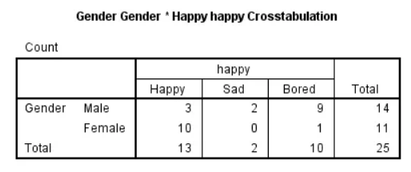
Chi square is used to test the relationship between two norminal or ordinal variables. (If p-value is less than 0.05)
Correlation measures the strength and direction (-1,1) of association between two quantitative variables.
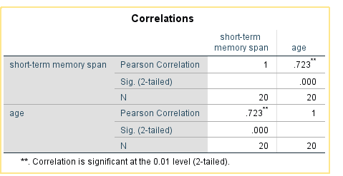
Regression predicts the value one variable(dependent) base on another variable(independent, predictor)
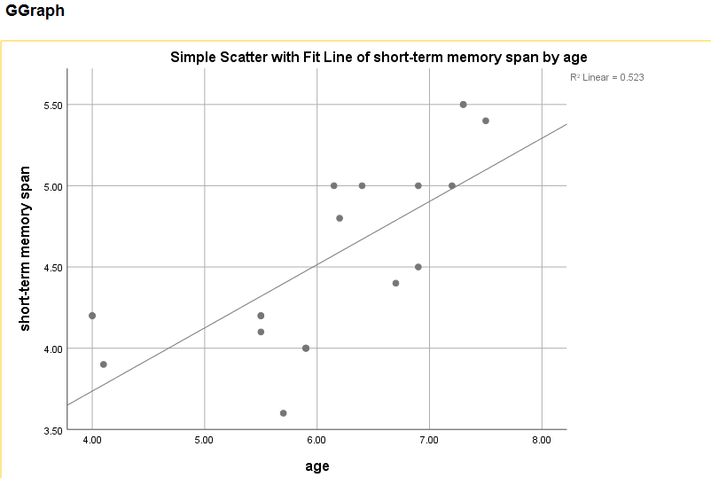
Y=2.2+0.39X

Exercise
- Find out how many girls vs boys in our dataset
- Make a pie chart for gender distribution
- What’s the average age of the children?
- Recode “Age” into “Age1”(below or equal 6 code as 1, above code as 2)
Recode “Read Ability” into “ReadAbility1” (below or equal to 6 code as 1, above code as 2)
- Crosstab between “Age1” and “ReadAbility1”
- Correlation between “Age” and “Memory Span”
- Linear Regression “Age” and “Memory Span”
- Plot “Age” and “Memory Span” with a trend line
- OLAP Cubes Average Grad in 6 years for Black/White weighted by Cohort counts

