**Fondren Fellows Project Proposal Submission Form**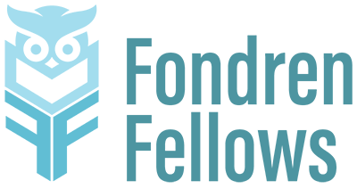

**Please complete this form by February 21 in order for your project to be considered for the 2025-2026 Fondren Fellows program.**

**If you don’t work in Fondren Library, we strongly suggest that you consult with a library colleague before proposing a project, especially if it involves time or resources from the library (such as IT support or assistance from Archives and Special Collections.) Contact** [**fondrenfellows@rice.edu**](mailto:fondrenfellows@rice.edu) **with any questions.**

*[Form revised 2/9/2025]*

**Name**

**Department/Organization**

**Email**

**Phone Number**

**Project Title**

**Provide a brief (up to 100-word) summary of the project that we can use in promoting it.**

**Describe the proposed project and its goals. What impact will this project have? How feasible is it to implement?**

**Why is this project appropriate for the Fondren Fellows program? How does it advance the library’s objectives, such as developing collections, enhancing services, offering workshops, and supporting scholarly communication?**

**How many fellows are you requesting (up to 3)? How would their work be broken down and managed?**

**Outline the key tasks that the Fondren Fellow(s) would work on.**

**What qualifications would you expect from students working on this project?**

**What would students learn through their participation in this project?**

**Please attach a copy of your proposed budget of up to $2000 (if applicable). This budget should include a brief budget narrative with a line-item breakdown of planned costs. In the narrative, explain why each line item is necessary to meet the project’s goals and how the cost was calculated. (Keep in mind: No money may be budgeted for faculty salary. Proposals not requesting project funds do not need to include a budget.)**