**Fondren Fellows Project Proposal Submission Form**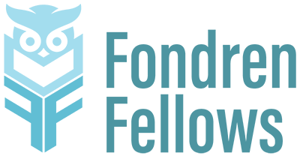

**Please complete this form by July 19, 2024 in order for your project to be considered for the 2024-2025 Fondren Fellows program.**

**Any questions can be directed to** [**fondrenfellows@rice.edu**](mailto:fondrenfellows@rice.edu)

**Name**

**Department/Organization**

**Email**

**Phone Number**

**Project Title**

**Proposal Summary (This is the shorter version of your proposal, which will be used to advertise your project to potential fellows and on the Fondren Fellows website. 50 words max.)**

**Please provide a brief (up to 500 word) summary of the proposed project, explaining why it is suitable for the Fondren Fellows program. What impact will this project have? How feasible is it to implement?**

**How many fellows are you requesting (up to 3)? How would their work be broken down and managed?**

**Outline the key tasks that the Fondren Fellow(s) would work on.**

**What qualifications would you expect from students working on this project?**

**What would students learn through their participation in this project?**

**If you don’t work in Fondren Library, please note who you would like to serve as the library liaison for your project. (If you don’t know, just write TBD.)**

**Please attach/provide a link/include in your email a copy of your proposed budget of up to $6000 (if applicable). This budget should include a brief budget narrative with a line-item breakdown of planned costs. In the narrative, explain why each line item is necessary to meet the project’s goals and how the cost was calculated. (Keep in mind: No money may be budgeted for faculty salary. A separate fund will be available for students traveling to present at conferences. Proposals not requesting project funds do not need to include a budget.)**