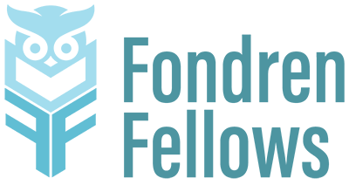
Fondren Fellows Project Proposal Submission Form

Please send your completed application form to fondrenfellows@rice.edu by February 20, 2026 at noon in order for your project to be considered for the 2026-2027 Fondren Fellows program.

Any questions can be directed to fondrenfellows@rice.edu

Name

Department/Organization

Email

Phone Number

Project Title

Proposal summary (This is the shorter version of your project description, which will be used to advertise your project. 50 words max.)

Please provide a brief (up to 500 word) description of the proposed project.

Why is the project appropriate for the Fondren Fellows program? How does it advance one or more of the library’s strategic objectives? How does it facilitate inquiry-based learning?

Describe the project’s feasibility. How will you ensure that this project is implemented over the academic year?

Outline the key tasks that the Fondren Fellow(s) would work on.

How many fellows are you requesting? How would their work be broken down and managed?

Describe the project’s anticipated outcomes and impact.

What qualifications would you expect from students working on this project?

What would students learn through their participation in this project?

Library liaison
If you don’t work in Fondren Library, please note who you would like to serve as the library liaison for your project. (If you don’t know, just write TBD.)

Please provide a copy of your proposed budget of up to $2000 (if applicable). This budget should include a brief budget narrative with a line-item breakdown of planned costs. In the narrative, explain why each line item is necessary to meet the project’s goals and how the cost was calculated. (Keep in mind: No money may be budgeted for faculty salary and proposals not requesting project funds do not need to include a budget.)

