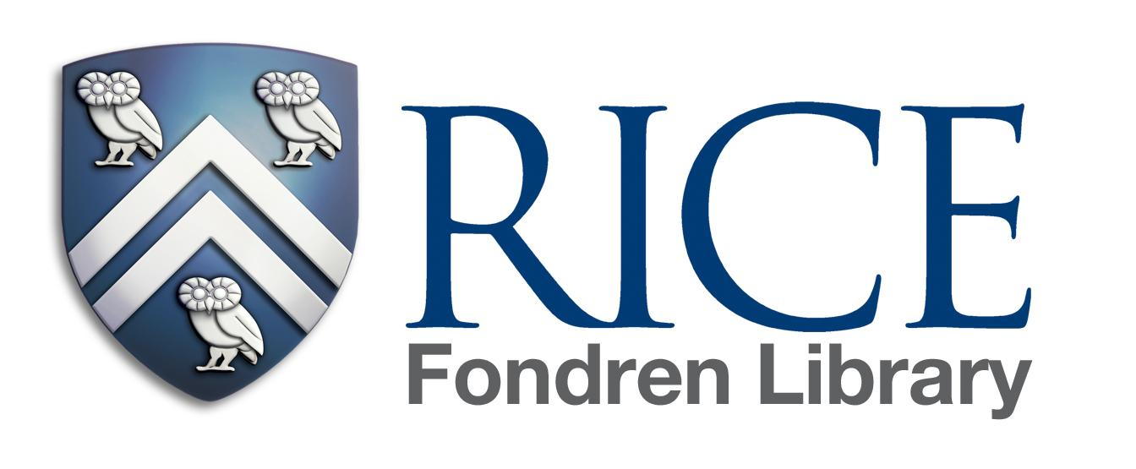

Spring 2022 Regular Hours: January 10, 2022 – May 3, 2022
Sunday | Monday | Tuesday | Wednesday | Thursday | Friday | Saturday
10am-2am | 6am-2am | 6am-2am | 6am-2am | 6am-2am | 6am-10pm | 9:00am - 7:00pm

Martin Luther King Weekend
Friday January 14 Close at 6:00pm
Saturday January 15 10:00am – 6:00pm
Sunday January 16 12:00noon – 6:00pm
Monday January 17 10:00am – 6:00pm
Tuesday January 18 Regular Hours Resume at 6:00am

Spring Recess
Thursday February 10 Close at 6:00pm
Friday February 11 6:00am – 6:00pm
Saturday February 12 10:00am – 6:00pm
Sunday February 13 Regular Hours Resume at 10am

Spring Break
Friday March 11 Close at 6:00pm Saturday March 12 10:00am – 6:00pm
Sunday March 13 12:00noon – 6:00pm
Monday – Thursday March 14 - 17 7:00am - 9:00pm Friday March 18 7:00am – 6:00pm
Saturday March 19 10:00am – 6:00pm
Sunday March 20 Regular Hours Resume at 10am

Final Exam Hours*
Friday April 22 Close at 2:00am
Saturday - Sunday April 23-24 6:00am - 2:00am
Monday - Thursday April 25 - April 28 Standard Hours
Friday - Sunday April 29 - May 1, 2021 6:00am - 2:00am
Monday May 2, 2021 Standard Hours
Tuesday May 3 Close at 6:00pm

Summer Hours Begin
Wednesday - Friday May 4 -6 7:00am – 6:00pm
Saturday (Commencement) May 7 1:00pm – 6:00pm
Sunday May 8 Closed
Monday – Friday May 9 – 13 7:00am – 6:00pm
Saturday May 14 10:00am – 6:00pm
Sunday May 15 Closed

Memorial Day
Saturday – Monday May 28 – 30 Closed

*For Rice students/staff/faculty with valid IDs at the west entrance. Visitor hours remain the same for finals week.

